DATA I/O Corporation


10525 Willows Road NE
Redmond, WA 98052
Phone: 1.425.881.6444
Phone: 1.800.247.5700 (press 2)
FAX: 425.867.6972
support@dataio.com

Algorithm Update on PS Series with OPTIMA Programmers

This document provides procedure to update algorithms on PP100 and PS-Series machines having OPTIMA Universal or FlashTop programmers with or without TaskLink for Windows, for PAL/PROM Version B2/2003 or later.

1. With windows Explorer navigate to I:\SPRINT\
2. If current PROM version is Ac2002,
I:\SPRINT\adapter.txt --> rename to adapter Ac_2002.txt
I:\SPRINT\lookup.txt --> rename to lookup Ac_2002.txt
I:\SPRINT\prom.exe --> rename to prom Ac_2002.txt
3. Down load PRSDZIPO.EXE and PALDZIPO from DIO Web page.
4. Copy this to Novell Server I:\SPRINT\ directory
5. Double click on PRSDZIPO.EXE to extract 5 files, such as:-
I:\SPRINT\adapter.txt
I:\SPRINT\b2_03dev.txt
I:\SPRINT\hotline.txt
I:\SPRINT\lookup.txt
I:\SPRINT\prom.exe

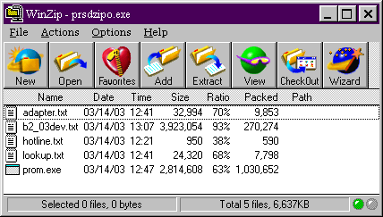

File b2_03dev.txt is the Device List file used by TaskLink to update Device Database for OPTIMA programmers on PP100/PS-Series. The name of this file within PRSDZIPO.exe will change with each release but the format would be AA_YYdev.txt where AA is Algo version and yy is year.

Similarly extract files from PADZIPO.exe

If you have TaskLink on Handler computer then continue step 6, otherwise cycle power to all Programmer Computers (PC104s).

6. Invoke TaskLink and ensure selected Programmer is PP/PS Series OPTIMA.
7. Select Tools and then Device Database Update

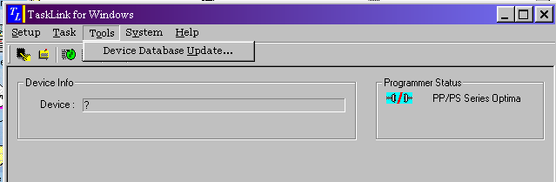

8. In the Windows "open" dialog, navigate to I\Sprint directory and select the current Device List File and click Open
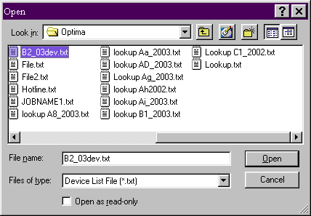
In this example B2_03dev.txt is selected.

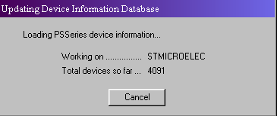
Once task Link has finished the update press OK.

When a Task is being created and device is selected,

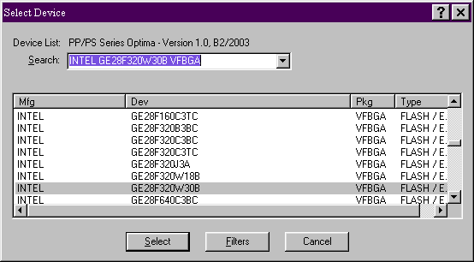

after the word "Device List" will be the Algorithm Version.

