

DATA I/O Corporation

10525 Willows Road NE
Redmond, WA 98052
Phone: 1.425.881.6444
Phone: 1.800.247.5700 (press 2)
FAX: 425.867.6972
FSE@dataio.com

Subject: PC104 BIOS Update Procedure

Model Affected: PP100 with Pentium PC104’s and PS300

- PURPOSE: To inform customers how to update the BIOS of the PC104. Note: this for the Pentium version of the PC104 Only. 486 does not have the PC Card.

2.0 TOOLS REQUIRED: NONE

3.0 SOFTWARE REQUIRED: BIOS.ZIP

- INSTRUCTIONS:

  - Copy the file V2.3.7.zip to a Floppy disk.
  - On the handler computer make a folder on the I:\ Named I:\BIOS.
  - Unzip the file BIOS.zip from the floppy disk into this folder I:\BIOS.
  - You will have 5 files as follows.
P5up.bat
Eraseeep.exe
Devel_tx.rom
Phlash.exe
Platform.bin

  - Go to the PC104 on the Autoview.
  - Then go to DOS.
  - Then change to the C:\ drive.
  - Then type MD P5sev
  - Then type I:\
  - Then type cd BIOS
  - Then type Copy *.* c:\P5sev.
  - You should see all 5 files copied to c:\P5sev.
  - Then type edit C:\config.sys and press the enter key.
  - Then type rem at the beginning of the first 2 lines as shown below.

Config.sys as it looks normally.
DEVICE=c:\dos\HIMEM.sys
DEVICE=c:\dos\EMM386.exe noems i=B000-B7FF x=E000-EFFF
FILES=30
STACKS=18,512
BUFFERS=10
DOS=high,umb
LASTDRIVE=z
REM DEVICE=c:\dos\RAMDRIVE.sys 15000 512 /e
DEVICE=c:\xram\xmsdsk.exe 64000

Config.sys as it will look after editing.
REM DEVICE=c:\dos\HIMEM.sys
REM DEVICE=c:\dos\EMM386.exe noems i=B000-B7FF x=E000-EFFF
FILES=30
STACKS=18,512
BUFFERS=10
DOS=high,umb
LASTDRIVE=z
REM DEVICE=c:\dos\RAMDRIVE.sys 15000 512 /e
DEVICE=c:\xram\xmsdsk.exe 64000

  - Exit and save config.sys.
  - Do control alt and del to reboot the PC104.
You will see that the PC104 did not boot properly press the D key to go to DOS.
  - Then go to the C:\ drive.
  - Type CD P5sev and enter.
DO NOT REMOVE POWER DURING THE REFLASHING PROCESS.
  - From C:\P5sev type P5up and enter.
  - You will see EEPROM is erased please press any key.

  - Press any key to reboot PC104. Then press F2 quickly to enter the BIOS setup. If you miss the BIOS setup repeat control, alt and del to reboot the PC104.
  - Go to Boot and load setup defaults.
  - Then exit and say changes.
  - Then press F2 quickly to enter the BIOS setup. If you miss the BIOS setup repeat control, alt and del to reboot the PC104.
  - Disable Floppy Drive A.
  - Disable USB.
  - Then go to Advanced and disable PS/2 mouse.
  - Then change Large Disk Access Mode to other.
  - Then exit and save changes.
  - Then go back to DOS.
  - Then Type Edit c:\config.sys and press enter.
  - Remove the rem from the first 2 lines as shown below.
DEVICE=c:\dos\HIMEM.sys
DEVICE=c:\dos\EMM386.exe noems i=B000-B7FF x=E000-EFFF
FILES=30
STACKS=18,512
BUFFERS=10
DOS=high,umb
LASTDRIVE=z
REM DEVICE=c:\dos\RAMDRIVE.sys 15000 512 /e
DEVICE=c:\xram\xmsdsk.exe 64000
  - Save the changes and exit editor.
  - Then do a control, Alt and del to reboot the PC104.
  - Then go to DOS.
  - Then go to C:\
  - Then type del P5sev and press enter. Say Y to remove all files.
  - Then type RD P5sev and press enter.
  - Then repeat this on all PC104’s that are Pentium.

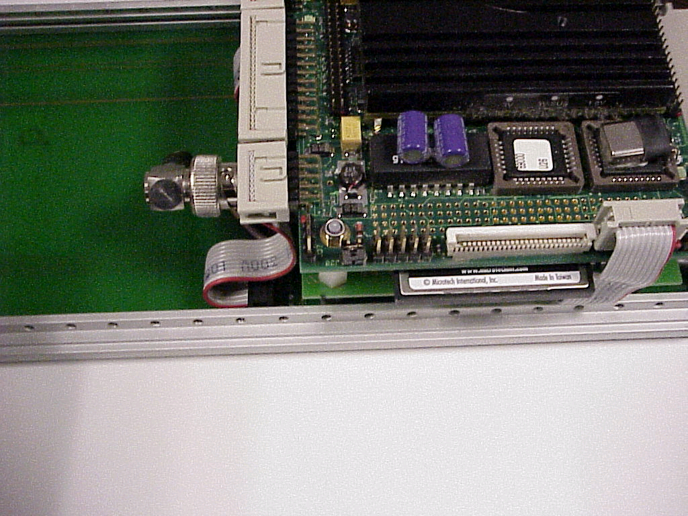

486 does not have this card.

