

DATA I/O Corporation

10525 Willows Road NE
Redmond, WA 98052
Phone: 1.425.881.6444
Phone: 1.800.247.5700 (press 2)
FAX: 425.867.6972
support@dataio.com

Subject: PP100/Ps200/300 Programmer Power on/off Procedure

This Alert is applicable to PP100 and PS-series on which the “Programmer” circuit breaker is connected only to the Programmer Computers (the PC104s). It does not apply to ‘older’ models on which the “Programmer” circuit breaker supplies power to the LCD monitor.

PP100/PS200/300 Customer Alert

To preempt potential problem on Optima programmers and their Programmer computers (PC104) when turning on power or off to PP100/PS-Series, please follow the following procedure:-

To power on the system follow the following procedures.
- Turn off the circuit breaker marked programmer on the rear of the system.
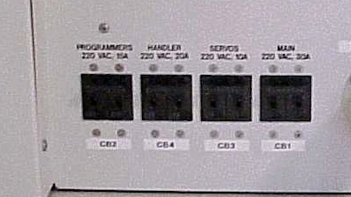
Turn off

- Turn on the main power switch on the front left of the machine.
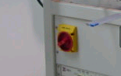

- Press the Start button on the Autopak.
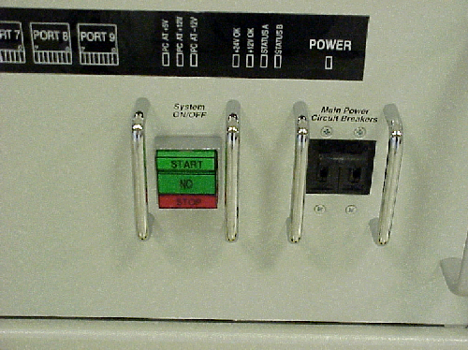

Start Button

- Handler computer will turn on and after Windows has been loaded, Log on to the Novel NetWare – no password is required, leave it blank.
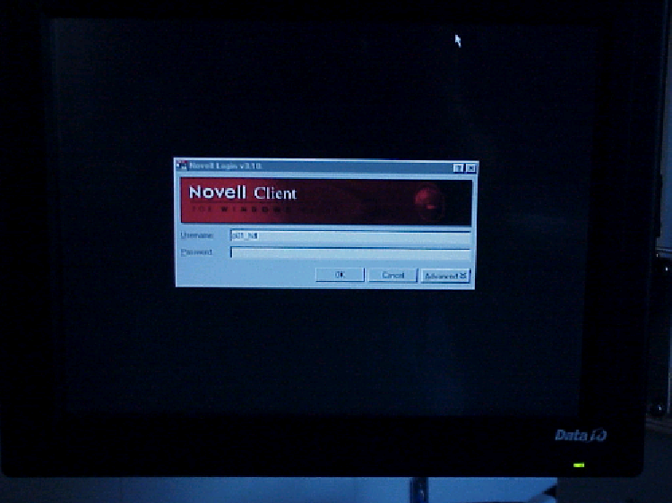

- Once the Network has logged in then turn on the circuit breaker marked “PROGRAMMERS”. Continue as normal from here.

To power down the system follow the following procedure.
1. First turn off the circuit breaker to the programmers.
Turn off

- Then shut down the handler computer from the Windows start button.
- If you have a laser you also need to shut down the laser from the Windows start button.
- Turn off the main power switch.

