

DATA I/O Corporation

10525 Willows Road NE
Redmond, WA 98052
Phone: 1.425.881.6444
Phone: 1.800.247.5700 (press 2)
FAX: 425.867.6972
pmhelp@dataio.com

Subject: To Inform Customers how to change the SMAC Head

Model Affected:PP100

1.0 TOOLS REQUIRED: Allen Key set SAE and Metric, Small flat blade screwdriver, 2ea 7mm box wrench or Small crescent wrench.

2.0 PARTS REQUIRED: Replacement SMAC head.

- INSTRUCTIONS:

Go to the gantry screen and move the head to a location that will be easy to reach. The tape input is a good location (front right).
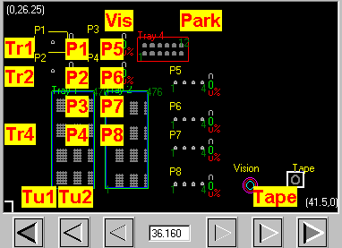
Move Here

Turn off the main power to the PP100.

Remove the vacuum line from the SMAC head.
Remove the cable from the SMAC head by removing the 2 screws.
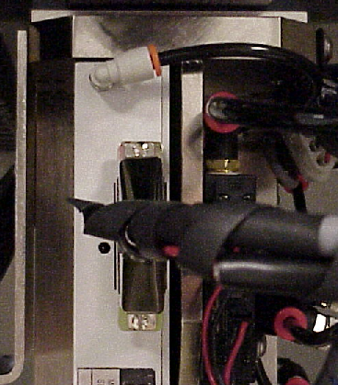
Remove vacuum line
Loosen these screws and remove cable.

Remove the 2 screws and remove the socket opener.
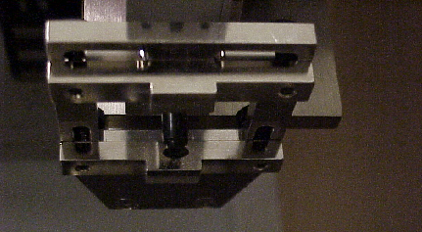

Remove these 2 screws.
3/32 Allen wrench.

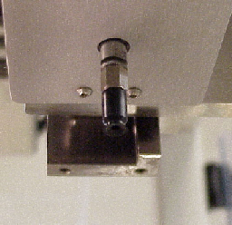

Loosen the lock nut from the socket opener air cylinder and unscrew the shaft.
Loosen lock nut and unthread the shaft.
7/16” box wrench

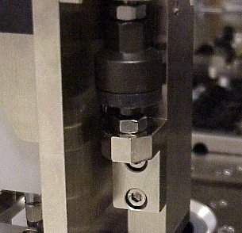

Hold this with a 9/16” box wrench.

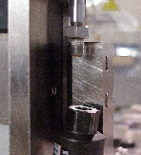

Next remove the 4 screws that hold the socket opener to the guide.
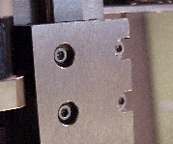
Remove these 4 screws.
2.5mm Allen wrench

Remove the 4 screws that hold the SMAC head in place. 2 on top and 2 on the bottom. Be careful to hold the SMAC head with 1 hand so it does not fall.

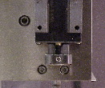
Remove these 2 screws. 2.5mm Allen wrench

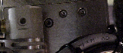
Remove these 2 screws. 2.5mm Allen wrench

Make sure that this lock nut is tight.

Install the new SMAC head in reverse order.

Make sure that all screws are tight.

If the SMAC head has any motion errors on power up check the cable to SMAC. If this cable is loose or not properly seated you can have motion errors.

You will need to recalibrate the vision before you run a job.

