

DATA I/O Corporation

10525 Willows Road NE
Redmond, WA 98052
Phone: 1.425.881.6444
Phone: 1.800.247.5700 (press 2)
FAX: 425.867.6972
pmhelp@dataio.com

Subject: OPTIMA programmer keycode / SMP update.

Model Affected: PP100

- PURPOSE: To inform customer’s how to update the programmer
keycode.

2.0 TOOLS REQUIRED:NONE

3.0 PARTS REQUIRED:NONE

- INSTRUCTIONS: You will receive a keycode from DIO service personnel.

  - Remove all the adapters from the programmers on the PP100.
  - Go to the Autoview and switch to the programmer you are going to update.
  - Go to dos. C:\ then type optitest.
  - You will be prompted to remove the adapters. Then press any key
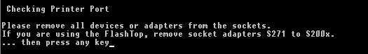
  - When the test is finished you will be at the main optitest menu.
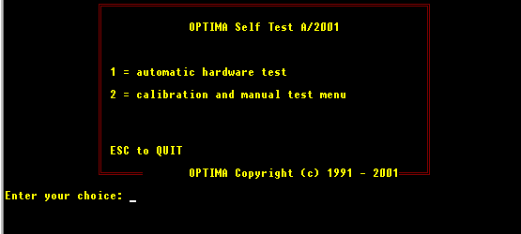
  - Press the hidden key 3.

  - Next type in the keycode exactly.
  - If you have typed it properly you will see this menu.

  - If you did not type the code correctly you will see this menu.
  - Try typing the number again. Remember the codes are serial number specific.
  - Run optitest again and select option 1 Automatic hardware test.
  - Then you will see the new SMP date on the right side.



