

DATA I/O Corporation

10525 Willows Road NE
Redmond, WA 98052
Phone: 1.425.881.6444
Phone: 1.800.247.5700 (press 2)
FAX: 425.867.6972
pmhelp@dataio.com

Subject: PP100 “Invalid Device” Error

Model Affected: PP100

- PURPOSE: To inform customer about an error on the PP100 and how over come it.

2.0 TOOLS REQUIRED: NONE

3.0 PARTS REQUIRED: NONE

- INSTRUCTIONS: If a job on the PP100 is started with the wrong adapter in the PP100 you will get the error message invalid device code.

  - To get around this error you need to quit AH400.

  - Then cycle the power on the Programmer’s with the correct adapter installed.

  - Next make sure that the PC104’s are on the main Sprint menu. See Figure 1.

  - Next go the directories M:\Machine1 and go to the sub directories of each programmer and delete the file default.job on each programmer directory.

  - Restart the AH400 job with the correct adapters.

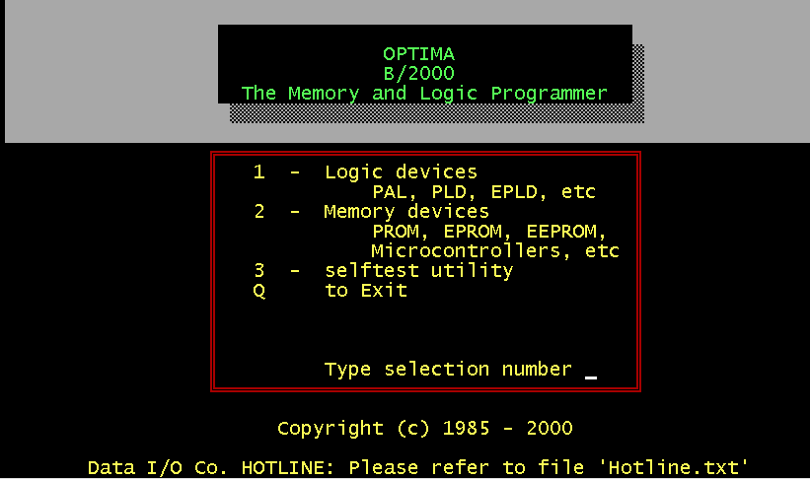

Figure 1

