

DATA I/O Corporation

10525 Willows Road NE
Redmond, WA 98052
Phone: 1.425.881.6444
Phone: 1.800.247.5700 (press 2)
FAX: 425.867.6972
pmhelp@dataio.com

Subject: PP100 PC104 Removal and Installation.

Model Affected: PP100

- PURPOSE: To inform customers how to change the PC014 on the PP100.

2.0 TOOLS REQUIRED: Small flat blade screwdriver.

3.0 PARTS REQUIRED: PC104.

- INSTRUCTIONS: Turn off the power to PC104 rack on the PP100. This is done by turning off the circuit breaker on the rear of the PP100. See figure 1.
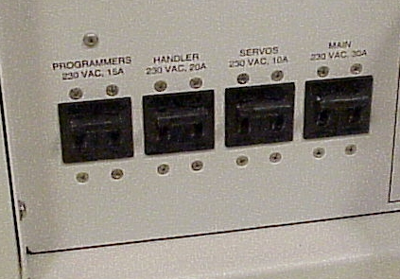
Circuit breaker for Programmers

Figure 1

  - If you have the old style Autoview you will need to remove the keyboard and monitor cables. See figure 2.

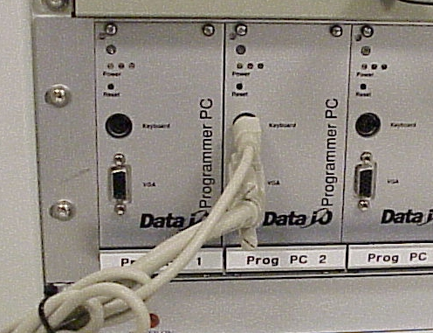

Figure 2

  - Remove the 4 screws that hold the PC014 in the rack. 2 on the top and 2 on the bottom. See figure 3.
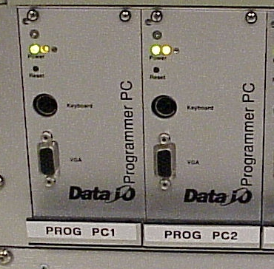

Remove these 4 screws.

Figure 3

  - Next remove the PC104 by sliding it out from the rack. See figure 4.

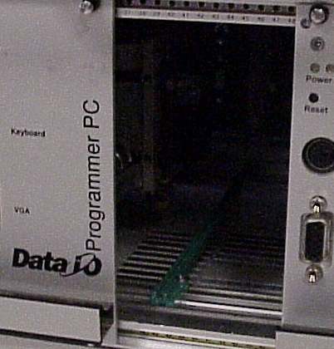

Figure 4

  - Next slide in the new PC104 into the empty space. Be careful to align the slides properly. Do not force the PC104. It should only take a little pressure to install. Tighten the 4 mounting screws.

  - Reinstall the cables if you have the old style Autoview.

  - Turn on the power to the PC104 rack. Programmer circuit breaker. See figure 1.

  - Go to the PC104 on the display. Insure that the Sprint menu comes up. All PC104’s come configured as Programmer 1. If you are have installed this PC104 on any programmer but 1 you need to edit the Autoexe.bat file.

  - Go to DOS on the PC104. The edit autoexe.bat. Edit the line that says Set Station = 1 and change this to the correct Programmer number. Example Set Station = 3.

