DATA I/O Corporation


10525 Willows Road NE
Redmond, WA 98052
Phone: 1.425.881.6444
Phone: 1.800.247.5700 (press 2)
FAX: 425.867.6972
support@dataio.com

Subject: PP100 Option-bay Motor Controller Modification

In some PP100 Option-bays, the Shuttle Stepper Motor Controller has an incorrect resistor installed. For P22 motors the correct value should be 20K ohms, while the one installed is 2.4K Ohms. This document outlines the procedure to replace this resistor.

Requirements:

For “P21” Shuttle Transfer Motor, which is 2” high, 20K Ohms, 1%, ¼ W 104-1118-001

For “P22” Shuttle Transfer Motor, which is 3” high, 15K Ohms, 1%, ¼ W 104-1105-001

Flat Screwdriver, 1/8” Hex nut driver
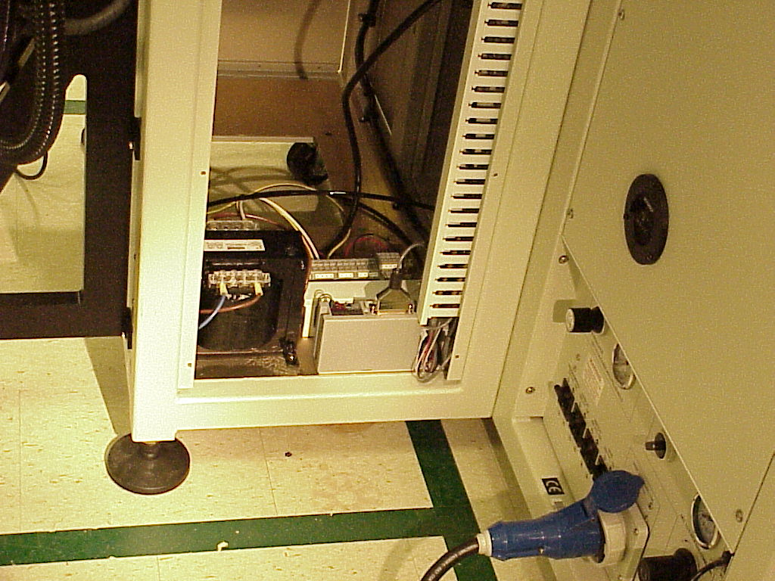

Open the panel on the Option-bay and locate the Stepper Motor Controller.

Remove the DB-25 Connector.

Remove the two hex-nuts (1/8”) holding the Controller on the base-plate.

Remove all the wires from the Screw Terminals.

Remove the Resistor and discard it.

Open the Stepper Motor Controller box pull out the PCB
Screw Terminal Connector Numbers and Wire Colors:-

- REMOTE - No Connection
- REF <----Resistor--|
- CURRENT <------------------|
- DUMP - No Connection
- VDC+ - RED Power
- VDC- - BLACK Power
- A+ - Red / Red
- A- - Black / Black
- B+ - Brown / Brown
- B- - Green / Green

Locate DIP Switch Number Three – it is marked as SW3.

On SW3
- Set #5 to OFF
- Set #6 to ON
- Other switches should be:-
- #1, #2, #3 & #4 = ON
- #7 and #8 = OFF

On SW2, all switches should be in the ON Position.

Push back the PCB and re-install the Controller on the base-plate.

Re-connect the wires on to the Screw Connector.

Install current limiting resistor between screw terminal #2 and #3
For P21, 2” motor 20K 104-1118-001
For P22, 3” motor 15K 104-1105-001.

Close the option bay and test the Shuttle Transfer Assembly
