
10525 Willows Road NE
Redmond, WA 98052
Phone: 1.425.881.6444
Phone: 1.800.247.5700 (press 2)
Fax: 425.867.6972
pmhelp@data-io.com

SUBJECT: PP100 Tray Mode & Direction Selection

- PURPOSE: To inform customers how to select Tray picking mode on PP100.
- INSTRUCTIONS: The software Version of AH400 3.5.14 has a new option for selecting the picking direction of the PNP head.
- The Winah400.ini file will contain 2 lines to select tray picking mode.
  - The line will be
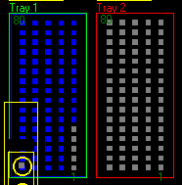

TrayType 3 or

TrayType 5
TrayType 3 means that the PNP head starts at bottom right and picks from bottom to top.

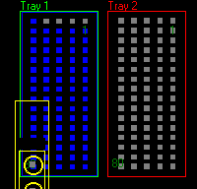
TrayType 5 means that the PNP will start picking at right rear of the tray and from right to left.

