DATA I/O Corporation


10525 Willows Road NE
Redmond, WA 98052
Phone: 1.425.881.6444
Phone: 1.800.247.5700 (press 2)
FAX: 425.867.6972
pmhelp@dataio.com

Subject: PP100 VTEK Tape-Out Sensor Locations and Adjustment

Purpose:
Explain the location of sensors and their adjustment on the V-TEK Tape-out Unit.

Air dampers can be used to speed up or slow down the motion of the stroke. The up and down motion should be equally set.
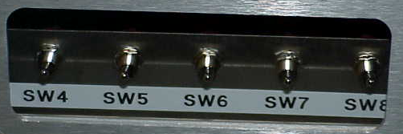
SW4 SW5 SW6 SW7 SW8
Vacuum Short - STROKE – Long Transfer Shutter Door

For Normal operation All switches must be in UP position
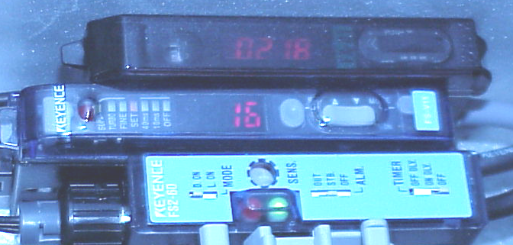
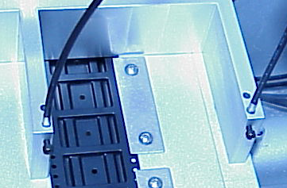
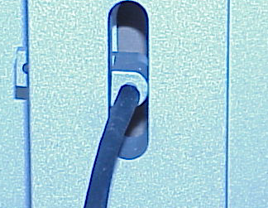
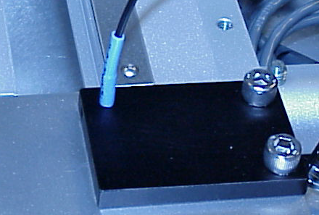
1. Device Jam Sensor
2. Cover Tape Sensor
3. Carrier Tape Sensor

Device Jam Sensor
Set the Fiber Optic Cables within the sensing range of each other by unscrewing the hex screw and rotate the cable until the light is shining through until the LED reads value as high as possible, typically around 200.

Set the Mode selection to "MODE"
There are two output modes, Output mode 1 and Output mode 2.
Set to either output 1 or Output 2 by turning the jog switch to the (+) or (-) side. Notice the blinking cursor bar alternates between Output 1 and Output 2. They both need to be set separately.

Press the Jog switch to Output mode 1. Change it from "Lnon" to "Dnon" by turning the jog switch to either (+) or (-) side. (L) and (D) are alternately displayed.

L=Light –ON and then D= Dark-ON

Turn the mode selections switch to "SET" current threshold value is displayed. Re-set the current threshold value to 90 by turning the jog switch to either (+) or (-) side to obtain the desired threshold value. Repeat step 2-4 to set the output mode 2

When both modes are set, set Mode switch to "RUN". For normal operation, both fault LEDs should be off.

To test the result, place any object or finger in front of the sensor, both fault lights should come on.
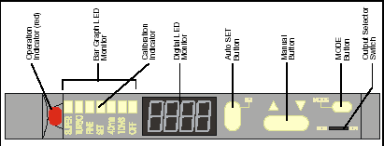
Cover Tape Sensor Module
Ensure that the Output Selector Switch is set to D.ON
Install a roll of cover tape on the unit. Press and release the (SET) button. The Calibration Indicator, [SET] LED bar, will light up. Remove the cover tape, press and release the (SET) button.
If there is no cover tape, the Red Operation LED will come on, indicating a Fault condition. Re-install the cover tape and resume normal operation.

Note: If an error occurs or the sensor fails to detect the Cover tape after switching from different type of cover tape, then the Cover Tape Sensor Module may need to be re-taught to sense that particular type of cover tape.

Carrier Tape Sensor Module
Ensure that that the switches are set as:-

Mode = D.ON, ALM = OUT and TIMER = OFF

Adjust the open end of fiber optic sensor cable so that the Green LED turns on when carrier tape is present. When carrier tape is completely removed the Red LED will turn on and buzzer will sound off.

