Customer Service Letter

To: UniSite, 2900, 39xx, ProMaster Customers | Date: 12-Jun-03
Subject: Special Data on UniFam Programmers | Document #: 983-0736-001

Products: UniSite, 2900, 39xx, ProMaster

Dear UniSite, 2900, 39xx and ProMaster Customers:

As embedded systems, UniSite, 2900, 39xx and ProMaster have certain RAM limitations not present in PC-based programming systems. These limitations present a challenge in dealing with files for:
- microcontroller devices with programmable arrays
- devices with features whose addresses are not contiguous to the main program array
- devices whose addresses in the processor's memory map fall outside of the programmer’s memory address capability.
Algorithm developers handle these situations in software and instruct you about how they are dealt with in a footnote that is displayed when the device is selected or in an application note available for downloading. For application notes, see ftp://ftp.dataio.com/appnotes/

One method to get data into the programmer’s RAM so that the target device can be properly programmed may involve multiple downloads of the same file, with each download using I/O Offset and I/O Address settings to specify what data is to be loaded from the file and where it is to go. The following example illustrates the multiple download method.

Multiple Download Method
MCT18F452 is programmed with two blocks of data that need to be loaded into the programmer. In the first block, the program data starts at Address 0 and goes through Address 400000 Hex. The maximum usable RAM in the programmer is around 7.5 Mbytes, which would fill up to Address 780000 Hex. The second block of data deals with Special Features in the device and is located by the compiler at address F00000 Hex, which is outside the programmer’s memory.

The algorithm deals with the shortage of memory by looking for the second block of data directly following the main program memory (at 400000 Hex in this case). This is described in an application note (referred to in the footnote) when the device is selected.

To program MCT18F452 using the multiple download method:

- In TaskLink, click Setup > Programmer Properties > and click the Memory tab.

- On the Memory tab, set:

I/O Offset = F00000
I/O Begin = 400000
I/O Block = 100
Automatic RAM Fill = Specific (00)

See Figure 1.

These Memory settings will take the data from the file starting at Address F00000 and load it into the programmer’s RAM starting at Address 400000 Hex. It will load 100 bytes of data after first filling all of RAM with zeroes.

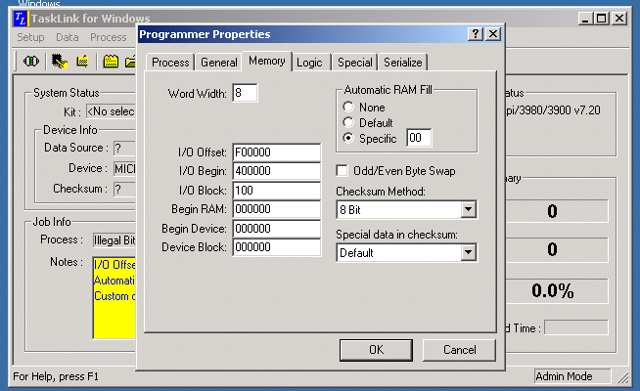
Figure 1: Memory tab settings for first download
- Click OK on the Memory tab.
- Click Data > Load RAM from > PC/Network File for the first download. See Figure 2.
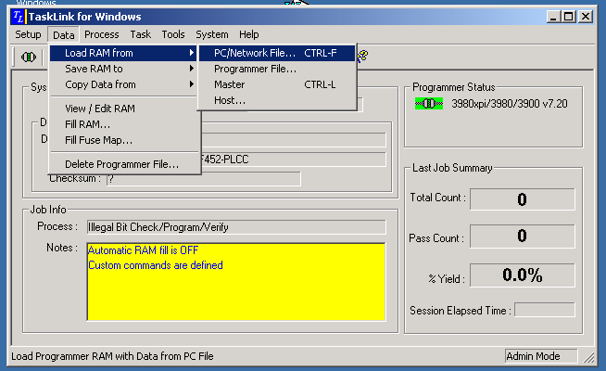
Figure 2: First download

- Return to the Memory tab and set:
I/O Offset = 00000000
I/O Begin = 00000000
I/O Block = 400000
Automatic RAM Fill = None

See Figure 3.
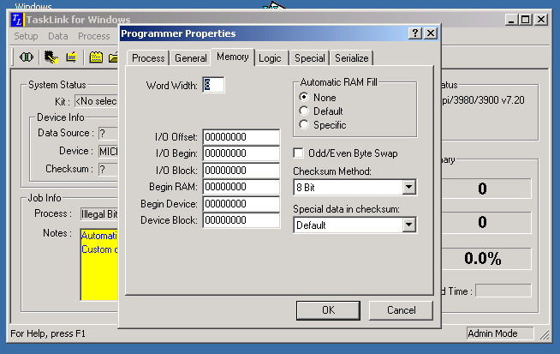
Figure 3: Memory tab settings for second download

- Click OK on the Memory tab.
- Click Data > Load RAM from > PC/Network File for the second download.
- You are now ready to process the device.

Notes
- Although the multiple download method is effective in an engineering environment, it is prone to human error. Extreme caution should be exercised if this method is used in a production environment.

- In a production environment, it is best to create a master (golden) device using the multiple download method, and then use the master device as your data source.

- It is also possible to save the programmer memory to a file once the data is loaded using the multiple download method. In TaskLink, click Data > Save RAM to > PC/Network File.
See Figure 4.
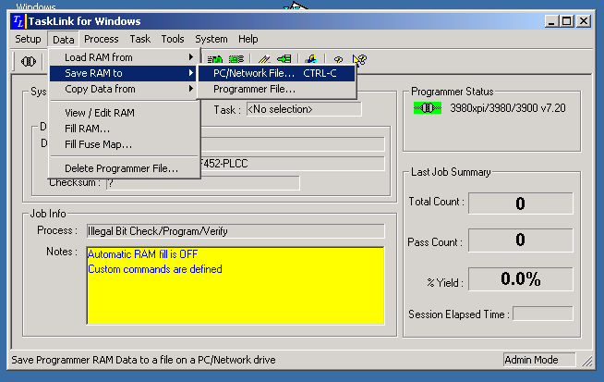
Figure 4: Save RAM to file

This file could then be used in production without concern about memory settings.

Be aware that during file transfer from the programmer's RAM to the destination file, the data will be translated to the specified file format. This process can take 30 minutes or more depending on file size.

