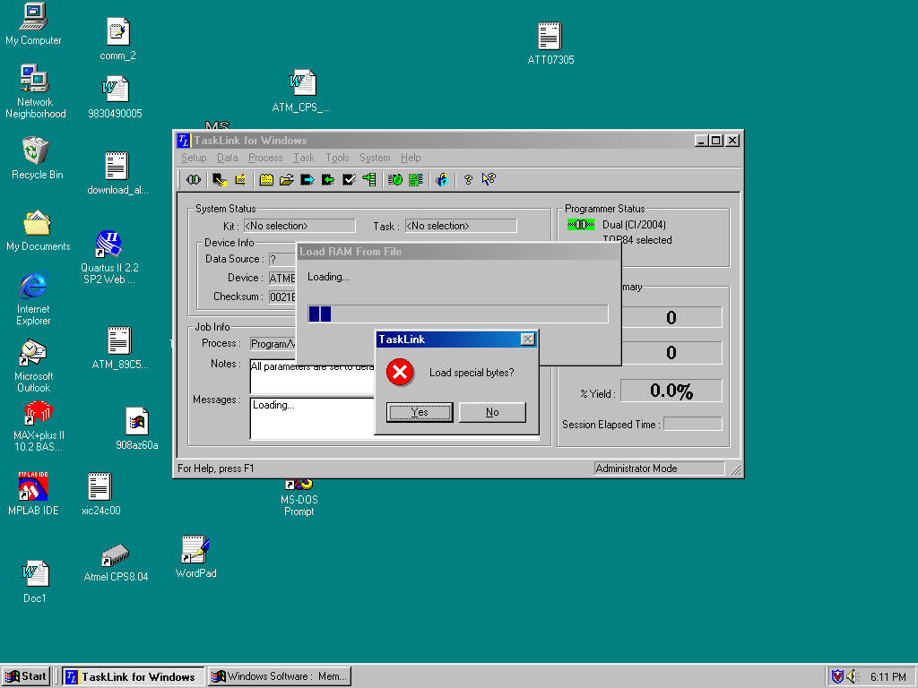

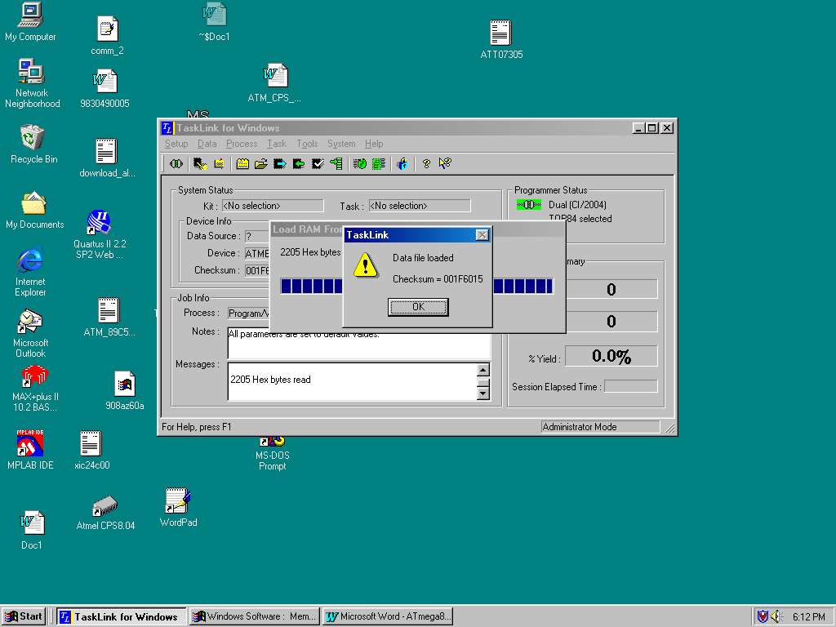

Not e that in the “Messages:” Box the comments show 2205 hex bytes loaded , which means your special data has been loaded.

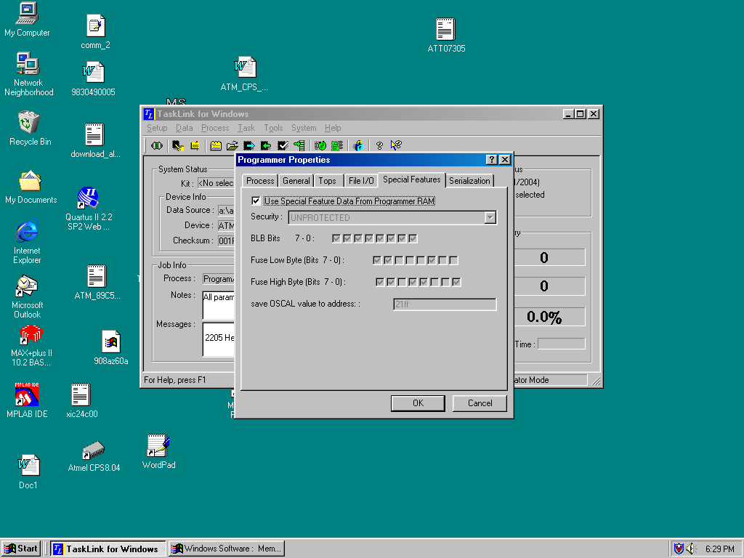

TaskLink does NOT appear to set the “Use Special Features Data From Progammer RAM” flag upon selecting “Yes” in the dialog box that asks “Load special bytes?” Therefore, I recommend you double check this setting, is Enabled.

